AWESOME ELECTRONIC RESOURCES

 | WEBSITE | WEBSITE ADDRESS
 | 123 Listening | www.123listening.com
 | 5 Minute English | 5minuteenglish.com
 | Aardvark’s English Forum | www.englishforum.com/00
 | ABC English | www.abcenglish.com
 | Agenda Web | www.agendaweb.org
 | All Kids Network | www.allkidsnetwork.com
 | Better @ English | www.betteratenglish.com
 | Boggles World | www.bogglesworldesl.com
 | Box | www.box.com
 | Breaking News English | www.breakingnewsenglish.com
 | British Council | http://learnenglish.britishcouncil.org/en
 | Busy Teacher | www.busyteacher.org
 | Can Teach | www.canteach.ca
 | Cram | www.cram.com
 | Creatubbles | www.creatubbles.com
 | Dave’s ESL Café | www.eslcafe.com
 | Designer Lessons | www.designerlessons.org
 | Dropbox | www.dropbox.com
 | Earn Videos | www.earnvideos.com
 | Edu Blogs | http://edublogs.org
 | Educational Voyage | www.educationalvoyage.com/esl.html
 | EFL Classroom 2.0 | http://community.eflclassroom.com/
 | ELT Base | www.eltbase.com
 | ELT Chat | www.eltchat.org
 | ELT Experiences | www.eltexperiences.com
 | Eng Go | www.enggo.com
 | Eng Vid | www.engvid.com
 | EnGames | www.engames.eu
 | Englisch Hilfen | www.englisch-hilfen.de/en
 | English At Home | www.english-at-home.com
 | English Banana | www.englishbanana.com
 | English Club | www.englishclub.com
 | English For Everyone | www.englishforeveryone.org
 | English Formus | www.englishforums.com
 | English Grammar | www.englishgrammar.org
 | English Page | www.englishpage.com
 | English Speak Like A Native | www.englishspeaklikenative.com
 | English Worksheets | www.englishwsheets.com
 | ESL 101 | www.esl101.com
 | ESL Base | www.eslbase.com
 | ESL Chestnut | www.eslchestnut.com
 | ESL Flow | www.eslflow.com
 | ESL Galaxy | www.esl-galaxy.com
 | ESL Kids Stuff | www.eslkidstuff.com
 | Randall's ESL Cyber Listening Lab | www.esl-lab.com
 | ESL Partyland | www.eslpartytown.com
 | ESL Pod | www.eslpod.com
 | ESL Printables | www.eslprintables.com
 | ESL Resource Center | www.eslsite.com
 | ESL Teacher’s Board | www.eslteachersboard.com
 | ESL Tower | www.esltower.com
 | ESL Treasure | www.esltreasure.com
 | ESL Video | www.eslvideo.com
 | ESL Writing | www.eslwriting.org
 | Everything ESL | www.everythingesl.net
 | Facebook | www.facebook.com
 | Film English | www.film-english.com
 | Flo Joe | www.flo-joe.co.uk
 | Free Coloring Pages | www.freecoloringpages.co.uk
 | Fun Brain | www.funbrain.com
 | Game Gal | www.thegamegal.com
 | Garfield | www.garfield.com/games
 | Gmail | www.gmail.com
 | Grammar Bytes! | www.chompchomp.com
 | Have Fun Teaching | www.havefunteaching.com
 | Heads Up English | http://www.headsupenglish.com
 | I Spilled The Beans | www.ispilledthebeans.com
 | IE Languages | www.ielanguages.com
 | ISL Collective | www.islcollective.com
 | Kahoot | www.kahoot.com
 | Krazy Dad | www.krazydad.com
 | Language Guide.org | www.languageguide.org
 | Larry Ferlazzo Blog | larryferlazzo.edublogs.org
 | Learn English Kids | http://learnenglishkids.britishcouncil.org/en
 | Learner.org | www.learner.org
 | Learning Apps | www.learningapps.org
 | Learning English Vocabulary & Grammar | www.learningenglishvocabularygrammar.com
 | Lesson Paths | www.lessonpaths.com
 | Lesson Stream | www.lessonstream.org
 | LinkedIn | za.linkedin.com/in/dianarenke
 | Listen & Write | www.listen-and-write.com
 | Live Worksheets | www.liveworksheets.com
 | Many Things | www.manythings.org
 | Michelle Henry | www.michellehenry.fr
 | Movie Segments for Warm-ups & Follow-ups | http://warmupsfollowups.blogspot.com/
 | Movie Segments to Assess Grammar Goals | http://moviesegmentstoassessgrammargoals.blogspot.com
 | Multi Media English | www.multimedia-english.com
 | National Geographic | www.nationalgeographic.com/tootandpuddle/games.html
 | Newsflash English | www.newsflashenglish.com
 | Off 2 Class | www.off2class.com
 | One Stop English | www.onestopenglish.com
 | Oomongzu | www.oomongzu.com
 | Osric | www.osric.com
 | Padlet | www.padlet.com
 | Perfect English Grammar | www.perfect-english-grammar.com
 | Pinterest | www.pinterest.com/teacherdianarenke
 | Powtoon | www.powtoon.com
 | Quizlet | www.quizlet.com
 | Rong Chang | www.rong-chang.com
 | Share My Lesson | www.sharemylesson.com
 | Sheppard Software | www.sheppardsoftware.com
 | Skype | www.skype.com
 | Slide Share | www.slideshare.net
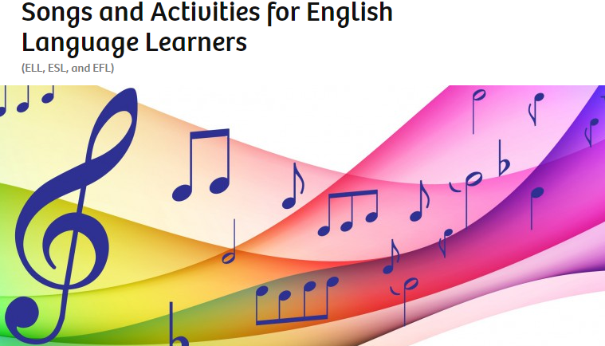 | Songs & Activities for English Language Learners | https://sandraheyersongs.com
 | Spelling Bee | http://www.learner.org/interactives/spelling/index.html
 | Spelling City | https://www.spellingcity.com
 | Stack the States | https://edshelf.com/profile/dianarenke
 | Teach It | www.teachitlanguages.co.uk
 | Teaching English | www.teachingenglish.org.uk
 | TED Education | www.tedxesl.com
 | TED Talks | www.ted.com
 | TEFL | www.tefl.com
 | TEFL | www.tefl.net
 | TEFL Tastic | www.tefltastic.wordpress.com
 | TEFLpedia | www.teflpedia.com
 | TES | www.tes.co.uk
 | TESALL | www.tesall.com
 | TESL Journal | http://iteslj.org
 | Tim’s Free English Lesson Plans | www.freeenglishlessonplans.com
 | TLS Books | www.tlsbooks.com
 | Tools For Educators | www.toolsforeducators.com
 | TOSS | http://trainingaustralia.org/toss
 | Tune Into English | www.tuneintoenglish.com
 | Using English | www.usingenglish.com
 | VK | www.vk.com/teacherdianarenke
 | Voice Thread | www.voicethread.com
 | VoiceTube | www.voicetube.com
 | Way Gook | www.waygook.org
 | Word Art | www.wordart.com
 | Word Press | www.wordpress.com
 | Worksheet Works | www.worksheetworks.com
 | Wyz Ant | www.wyzant.com
 | Your Agora | www.youragora.com
 | Your English Source | www.yourenglishsource.com

